# iLovePDF

## Definition

**# Source**: **Windows ScreenShots (using Lightshot Program) From Site -> https://www.ilovepdf.com/ at [8/29/2025]**

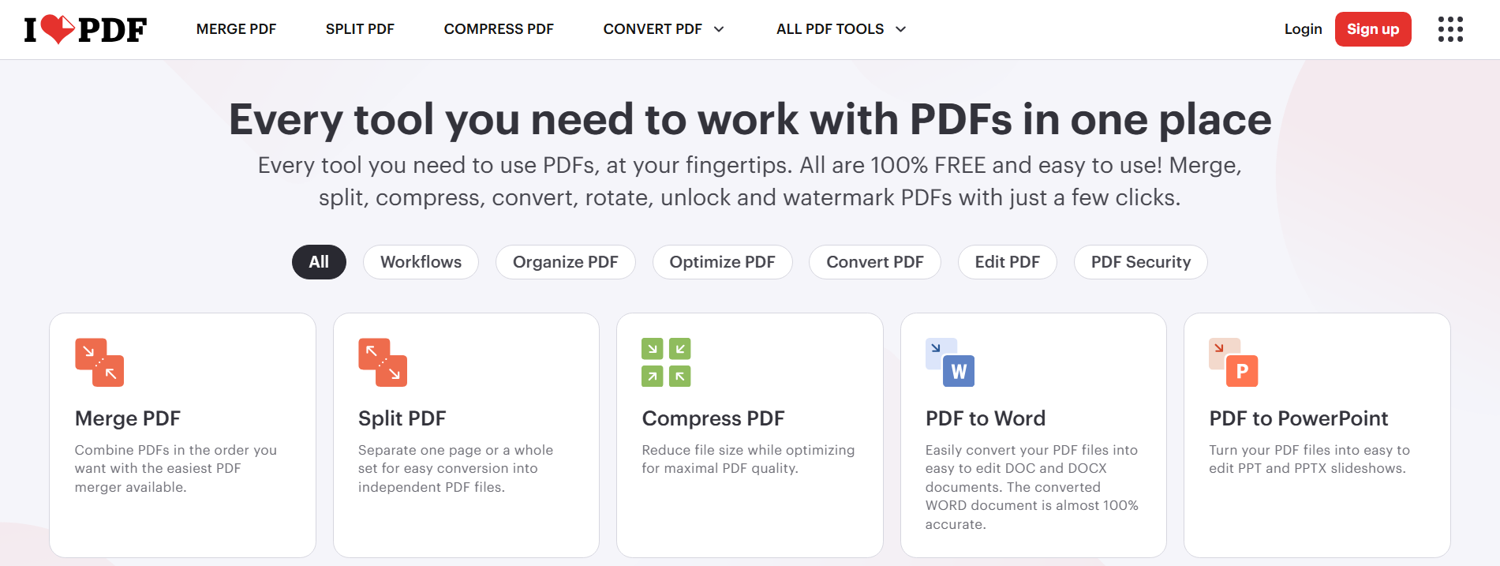

**# Source**: **Chatgpt (GPT-5-Standard) at [8/29/2025]**

**iLovePDF** is an **online PDF management platform** (also with mobile apps and a desktop version) that provides tools for working with PDF files.

It is very similar to Sejda, offering an all-in-one solution for PDF tasks.

✅ **It is mainly used for:**

* **Edit & Annotate** → add text, images, comments, highlight, or draw on PDFs.
* **Merge & Split** → combine multiple PDFs, split by page range, or extract pages.
* **Compress** → reduce file size while keeping good quality.
* **Convert from PDF** → PDF to Word, Excel, PowerPoint, JPG.
* **Convert to PDF** → Word, Excel, PowerPoint, JPG, HTML → PDF.
* **Organize pages** → rotate, reorder, delete, or extract pages.
* **Protect & Unlock** → set passwords, remove restrictions.
* **eSignatures** → request or add electronic signatures.
* **Watermarks & Page numbers** → customize PDFs for branding or organization.
* **Scan & OCR** → turn scanned documents or images into editable/searchable text.
* **Batch Processing** → handle multiple PDFs at once (compress, convert, rename, etc.).

🔹 **Why people use iLovePDF**:

* **Free online use** (with limits).
* **User-friendly** → clean design, easy drag-and-drop.
* **Cross-platform** → works on Web, Windows, macOS, iOS, Android.
* **Integration** → connects with Google Drive, Dropbox, OneDrive.

👉 In short: **iLovePDF = “Swiss army knife” for PDF files** (like Sejda, Smallpdf, Adobe Acrobat online).